DR. AMBEDKAR COLLEGE, DEEKSHA BHOOMI, NAGPUR

Date: 7th Sept 2022
Name of the Programme: Debate Competition
Name of the Judges: 1. Adv. Piyush Kadam
2. Adv. Rohan Chabra
Name of Program Co-ordinators: 1. Dr. Mrs. Sandhya Kalamdhad
2. Mrs. Vaishali A. Sukhdeve
3. Ms. Shilpa Rathod
4. Ms. Sarika Kamdi
Number of Attendees: 73
Number of Participants: 14
Name of Venue: Seminar Hall of Department of Law, under the aegis of Criminal Law Club, Dr. Ambedkar College Deeksha Bhoomi, Nagpur

NOTICE
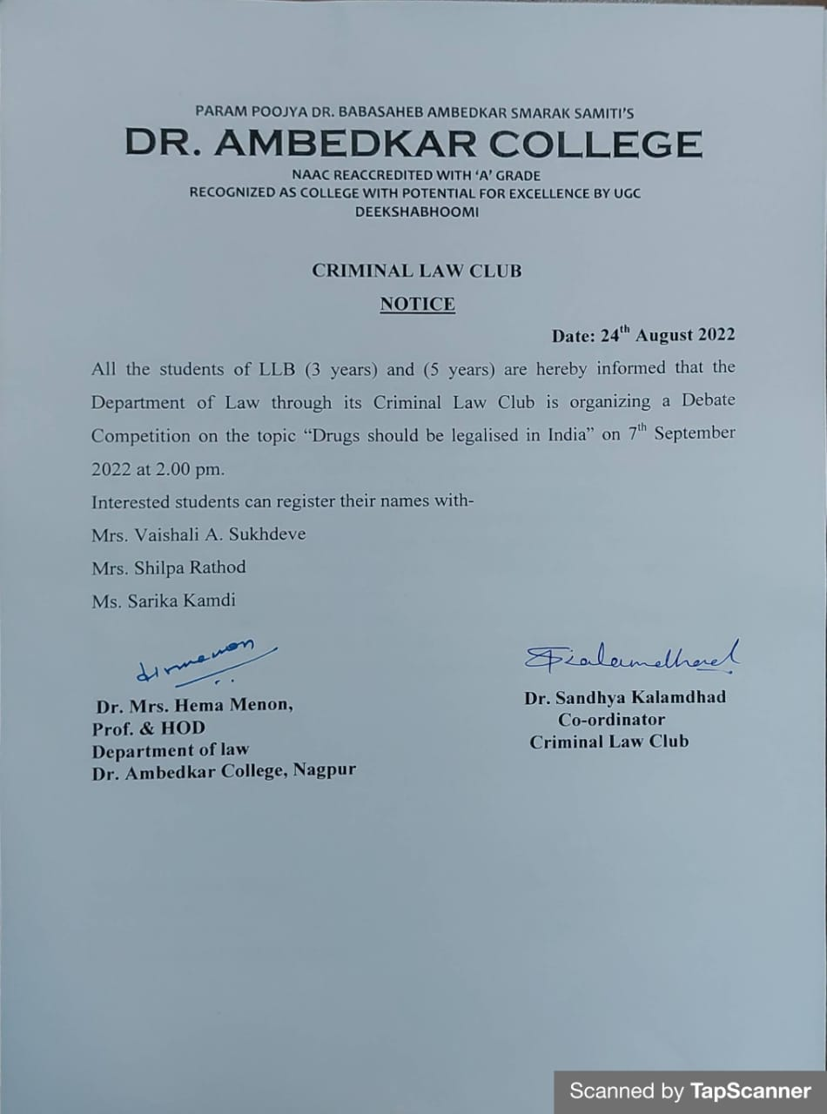

REPORT ON DEBATE COMPETITION

The Criminal Law Club of the Department of Law, Dr. Ambedkar College, Deekshabhoomi Nagpur, has conducted the Intra-college Debate Competition on 7th Sept 2022 for the students of LL. B 3 years and 5 years course. The topic of the debate was “DRUGS SHOULD BE LEGALISED IN INDIA?”
Total 73 attendees were present in the programme, out of which 14 participants had competed in the competition. Each participant had to speak either for or against the motion under the time duration of 5 minutes. The competition was ably judged by Adv. Piyush Kadam, Advocate practicing in District Court and High Court, Nagpur and Adv. Rohan Chabbra, Advocate practicing in District Court and High Court, Nagpur.
The program commenced with the welcome address by Dr. H.V. Menon, Head Department of Law to the well acclaimed Judges, the faculty members of the departments, treasured invitees and the participants. The rules of the competition were read out before commencing the competition. All the participants were invited individually to express their views on the topic of the competition. There were so many notable points presented by each participant and brought out their hidden intellect. At the end 2 minutes time allowed to the first speakers favouring the motion and against the motion for rebuttal.
At the end both the judges have enlightened with the words of inspiration and motivation to the participants and students and provided few encouraging tips in the student’s interest.
The first prize bagged by Ms. Nishtha Singh, Ms. Sneha Badhiye secured the second prized and Ms. Apurva Pittalwar is the third recipient of prize. The special recognition has been given to all the Participants for their excellent performance.
The Programme was compared by Ms. Shilpa Rathod under the guidance & supervision of Dr. Mrs. Sandhya Kalamdhad, Associate Professor and Organising secretary of Criminal Law Club of Department of law.
The event concluded with vote of thanks proposed by Mrs. Vaishali A. Sukhdeve to the jury members and also to everyone who was present to witness the event.

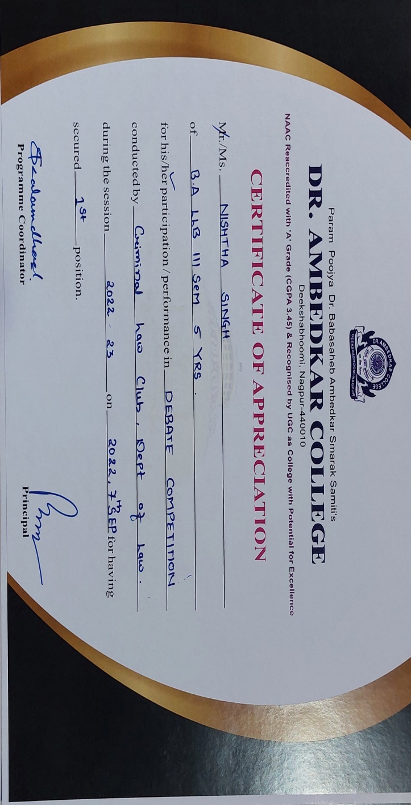
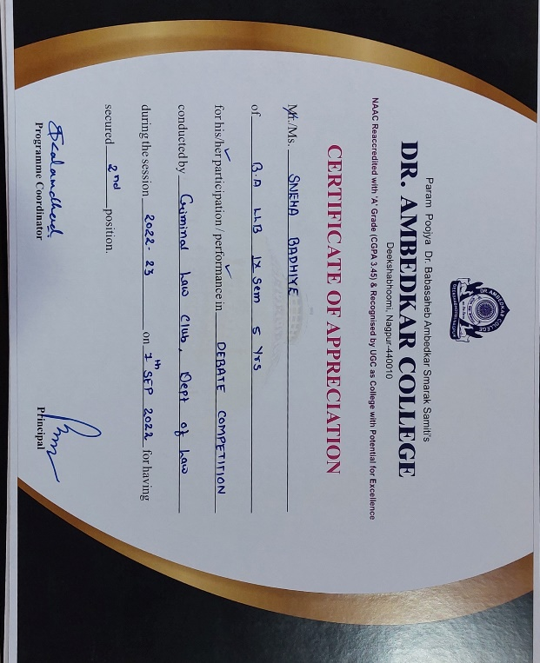 | 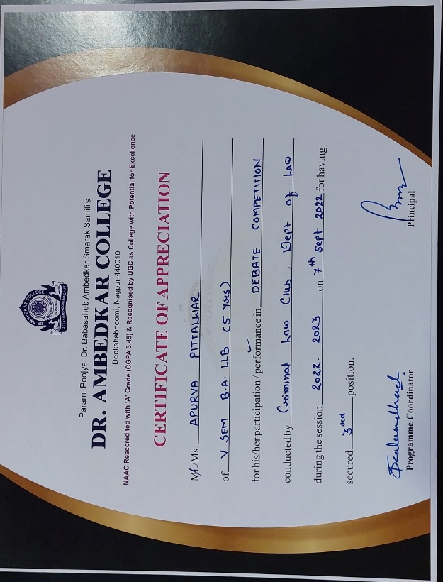

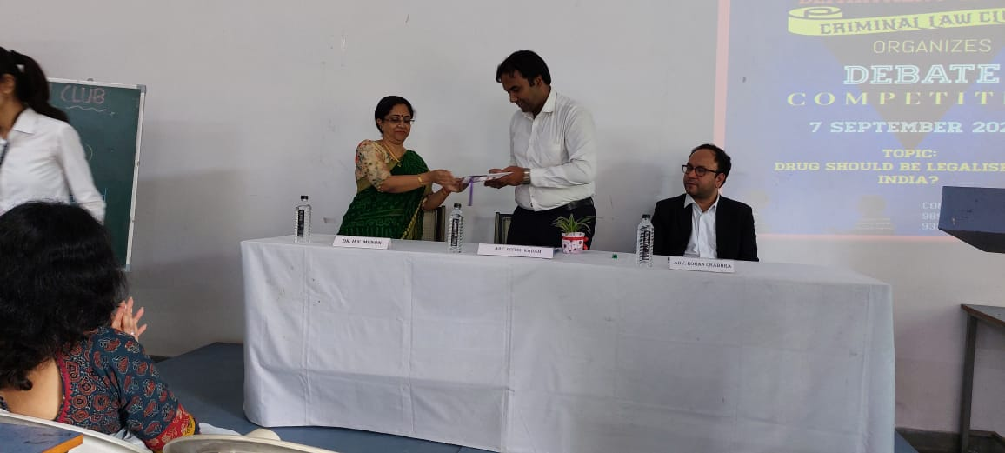
(Dr. H.V Menon Head Department of Law Presenting the sapling and Memento to the Guest of the competition Adv. Piyush Kadam)
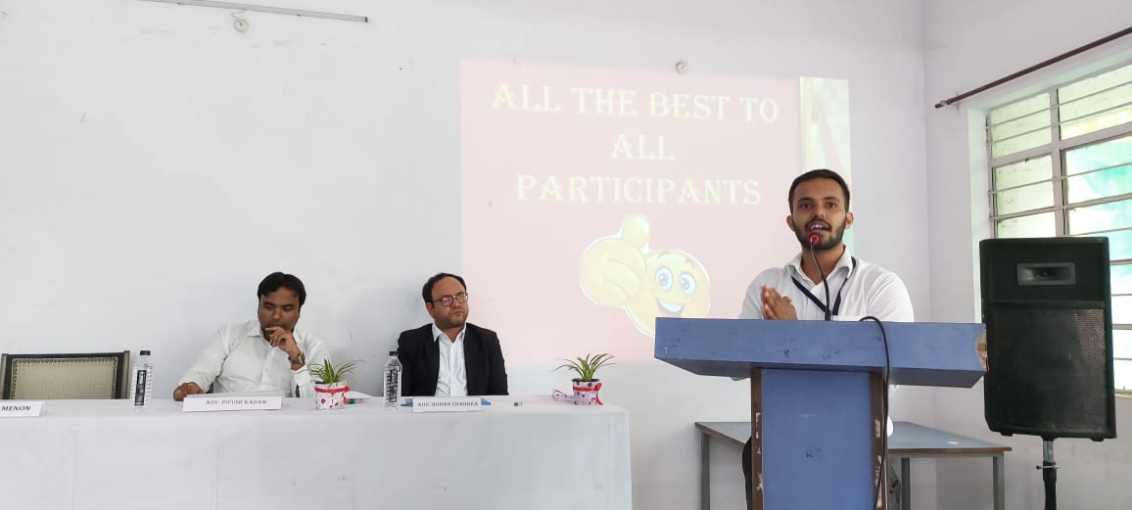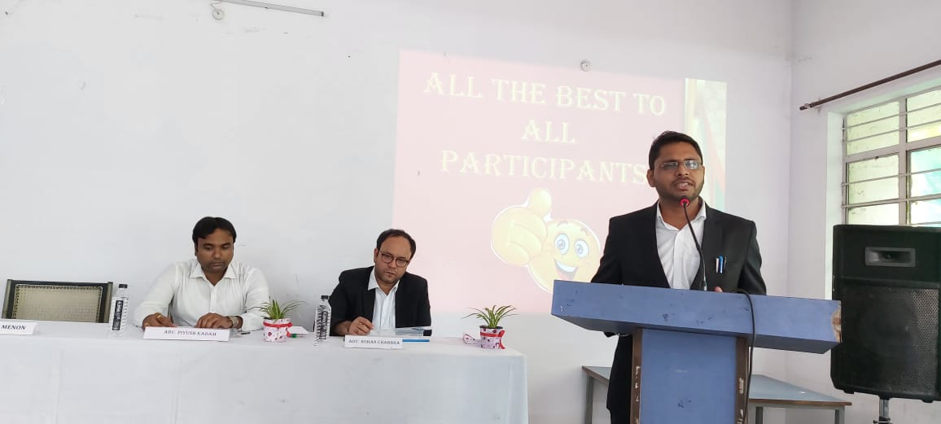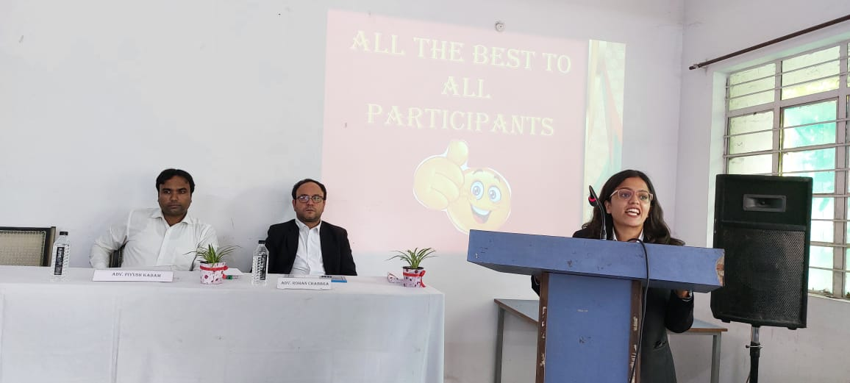
(The Participants presenting their views for and against the motion in the competition)
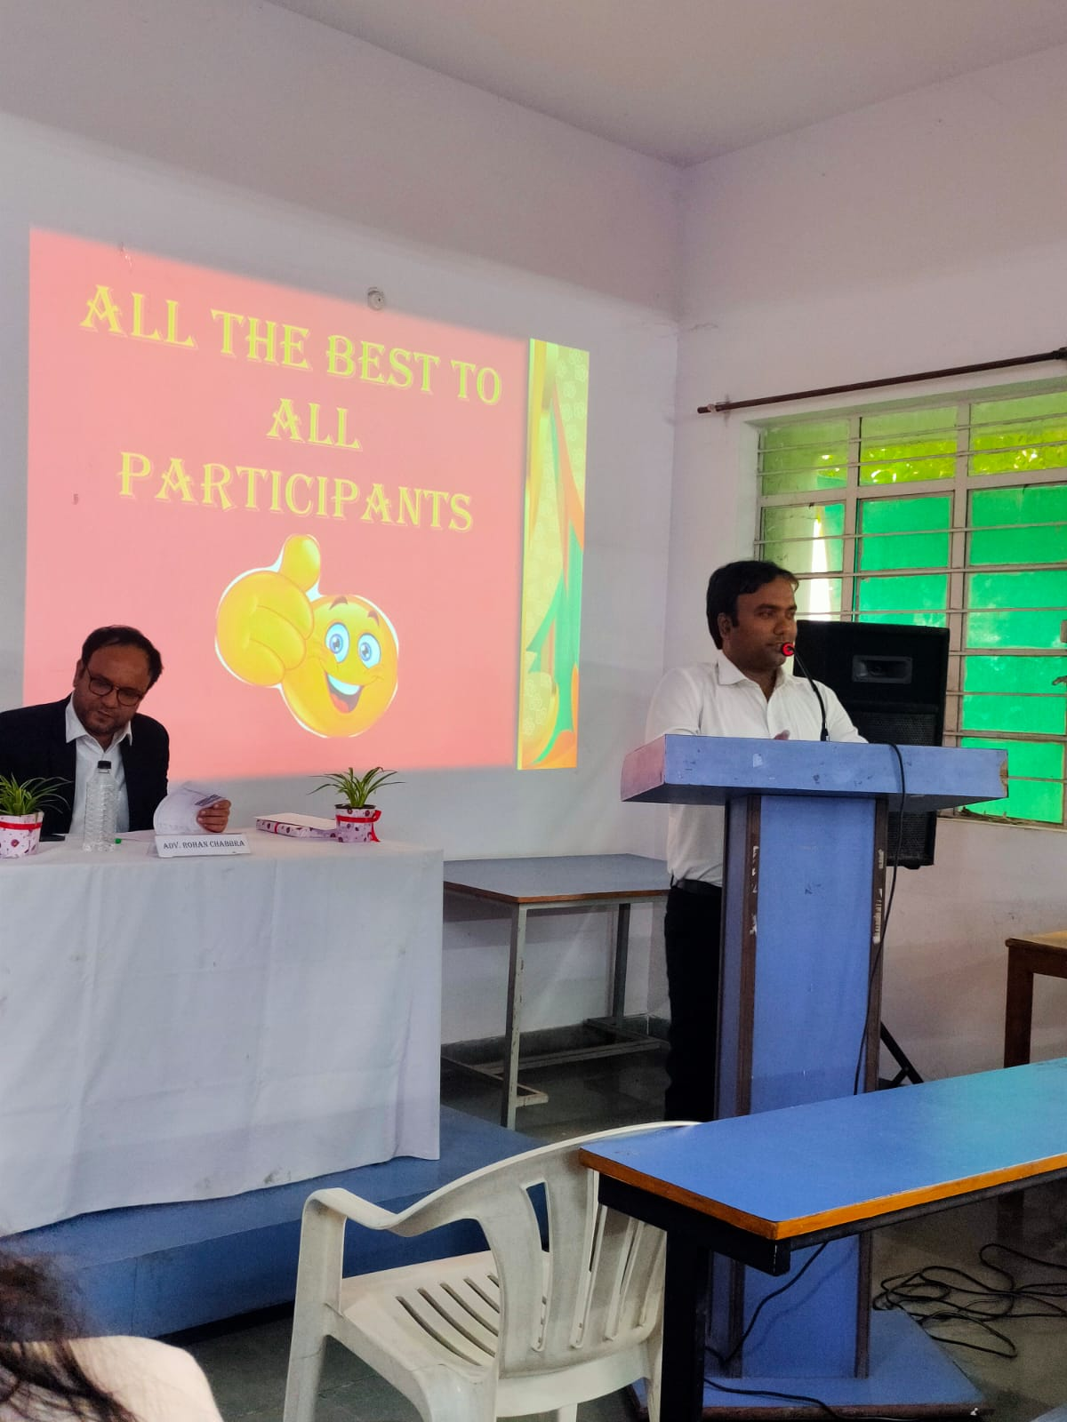
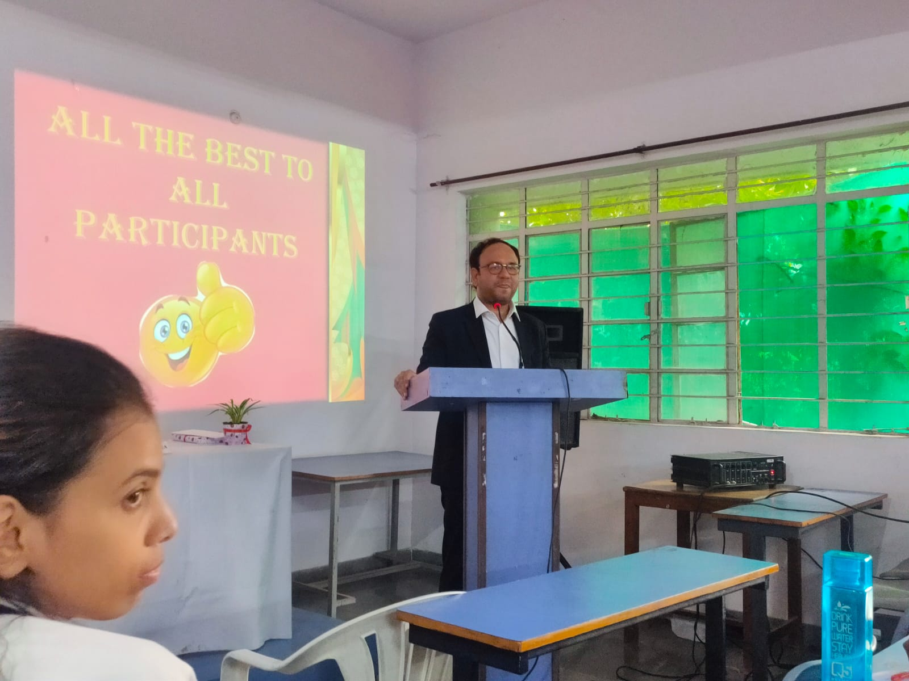
(Judges of the Debate Competition addressing the audience)

